Test Summary
Latchup
Table 1: Latchup Overview for the ADRF5144
 | RF input (GHz, dBm) | VDD (V) | IDD (mA) | VSS (V) | ISS (mA) | CTRL (V) | Output tone (GHz, dBm)
Typical Board | 1, -5 | 3.45 | >.130 | -3.45 | >.510 | 0 | 1, ???
Transient
Table 2: Transient Overview for the ADRF5144
 | RF input (GHz, dBm) | VDD (V) | IDD (mA) | VSS (V) | ISS (mA) | CTRL (V) | Output tone (GHz, dBm)
Typical Board | 1, -5 | 3.15 | <.130 | -3.15 | <.510 | 0 | 1, ???
Brief Test Setup
- Connect all relevant equipment to the chassis (1x rf gen, 1x power card)
- Connect the eval board to the appropriate equipment – see connection diagram (1x rf gen, 1x power cards, spectrum analyzer)
- Connect the PXIe4081 to the beam’s TTL Signal
- If latchup, heat die to 135℃. If transient, keep at room temperature
- Use the LabVIEW vi to configure the run information, the power cards, the rf sources
- Use ACE + SDP connector to configure the eval board
- Set up the python register collection script
- Run the LabVIEW power supply reading and the python register read
- Irradiate beam
- End beam irradiation
- End LabVIEW power supply reading and the python register read
- Evaluate the data
- Offload data collection folder to separate pc to read

Equipment
- NI PXI 1095 Chassis
  - 8880 controller
  - 4163 smu card
  - 4081 dmm
- 1x Signal Generators (Hittite Sig Gens)
- Spectrum Analyzer
- ADRF5050
- >2x rf cables
- >1x 2.4mm to 2.92 FF RF connector
- >2x Right Angle MF RF connector
- >1x HS-USB-GPIB connectors
- 2 – 3 x GPIB connectors
- >1x 50 ohm screw terminations
- Camera
- Omega Thermometer
- Thermocouples
Procedure
NOTES
Slot 6 cable has some voltage drop on it (significant enough to account for it)
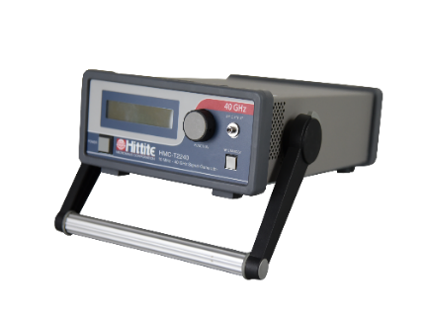
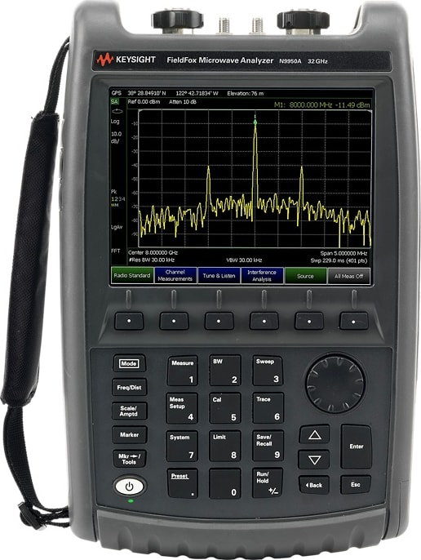
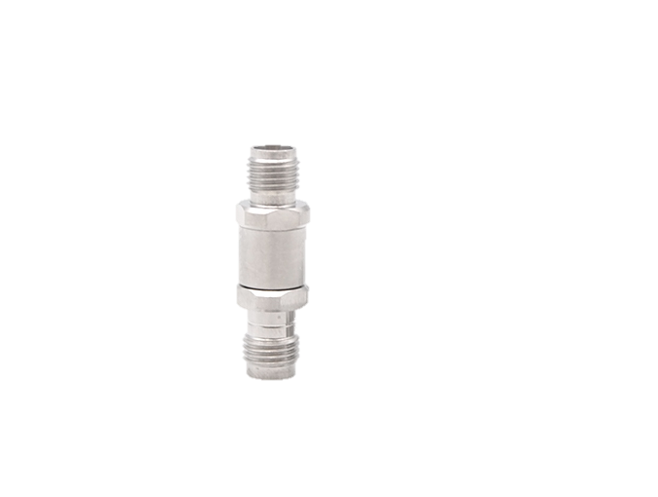
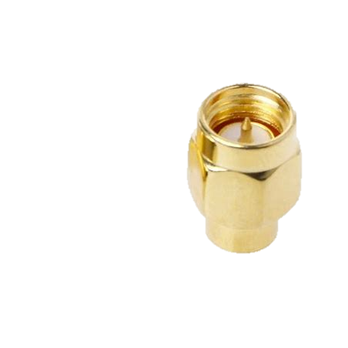
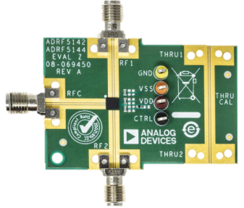
Initial Configuration

- Ensure the device is powered off
- Connect one RF Hittite Signal Generator to RFC
  - GPIB 27
- Connect a HS-USB-GPIB connector on the Hittite Signal Generator to the NI Tester
- Connect RF2 to Spec Analyzer
- Connect the power supply cables to the 4163
Green 3.3v VDD | Ch_0
Blue -3.3 VSS | Ch_1
Brown 0v CTRL | Ch_2

- Connect the PxIe4081 to the beam’s TTL logic via bnc /banana jack adaptor on the patch panel
- Connect GND to the GND on the 4163 (slot 3) of the PXI 1095 tester
  - Can connect the PXIe4081 to the shared ground node, but not required
- If latchup test, put the heat gun on the part and
- Open LabVIEW on NI Tester
- Go to C:\ Git\Rad-Effects-Test-Software\SEE_PXI_TopBench.lvproj
  - If there is a pop up, just press “load with selected”
- If not running, press white arrow
- Configure the “Data Block”
  - Change values in the “Run Data Input” (Green Block)
    - RUN FOLDER
    - DUT
    - ION
    - BOARD NUMBER
    - EFFECTVE LET
    - TEST TYPE (NOTE ONLY DOING LATCHUP THIS CAMPAIGN)
  - Press “Apply Data” in the “Output Echo” Block (right block)
  - Confirm the values are desired
  - Ensure the “Changes Applied?” indicator is bright green
  - Press the Exit button
- Configure the “Power Block”
  - Select “PXIe4163”
    - Select Active Channel 0 through Active Channel 3 (bright green when selected)
    - Refer to Tables 3 and 4 for the voltage necessary for the device and the channel name
      - AVOID USING SPACES AND PERIODS IN NAMES
    - “Aperture Time” should be .001 seconds (could go to .0001 seconds if you want higher resolution)
    - Current Limit should be .05
    - Press Apply Changes
    - Check DCPowerInformantionClusterArray for one object
Latchup
Table 3: LATCHUP Expected Voltage/Current values along with the channel names of each configured power supply
 | VDD (V) | IDD (mA) | VSS (V) | ISS (mA) | CTRL (V)
Typical Board | 3.6 | .155 < | -3.6 | .530 < | 0
Channel Name | VDD |  | VSS |  | EN

Transient
Table 4: TRANSIENT Expected Voltage/Current values along with the channel names of each configured power supply
 | VDD (V) | IDD (mA) | VSS (V) | ISS (mA) | CTRL (V)
Typical Board | .3? | < .155 | -.3 | <.530 | 0
Channel Name | VDD |  | VSS |  | EN

- Configure the “RF Block”
  - RFC = 1Ghz , -5dBm
    - Select the drop down on “VISA resource name”
    - Select GPIB2::27::INSTR
    - Set “frequency” to 1
    - Set “power” to -5
    - Press “Power On”
    - Press Apply Configuration
    - Check the “RF Block Output Echo” for the configuration
- Configure the Oscilloscope Block
  - Just open and close it. This functionality will be added later
- Begin Data Collection Block
- Confirm that the data is being collected at the levels you are expecting for a unconfigured board
- Confirm that a folder has been created at the run folder specified during STEP 14 A I
- Review the spectrum analyzer output. If there is a tone at 1GHz greater than -7 dBm, you have configured the part properly
- Prepare the beam for irradiation
- On the LabVIEW script, press “record data toggle” when you want to begin
- When the beam is on, write down the time stamp in a text file (you’ll have a time stamp at the beginning of the LabVIEW recording and in the python capture, but this is for being closer to the actual beam time
- Once run is complete, press “record data toggle” on the LabVIEW script
- You have completed a run

